The Last Dying Treasure
A film Written By: Naiyahmi Taylor, Deeyonah Wilson, Asian Miller Nyzon Obenson

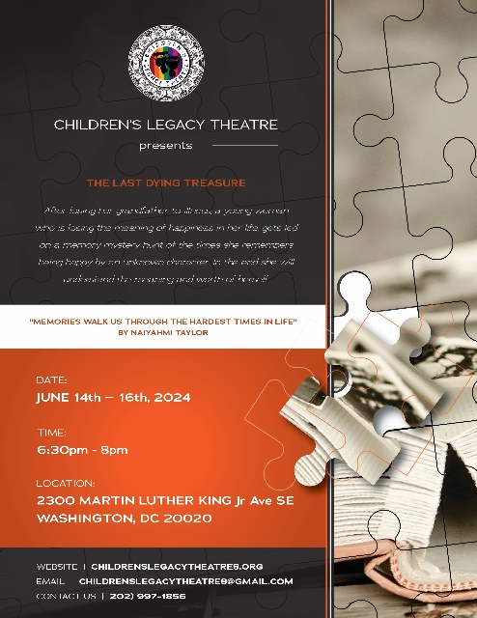

Amber is losing her sense of happiness. Hunted by an unknown stranger, who helps Amber regain her happiness and secure her future.

Solomon G. Brown CC
2300 Martin Luther King, Jr. Ave SE, Washington, DC 20020

June 14th – 16th, 2024 @ 6:30PM

Come out and experience young Black excellence at its finest!

Dear Friends of CLT:

Welcome to CLT's 2024/2025 theatre season! We are proud to present diverse productions that will entertain, provoke, and inspire you. First up, we have “The Last Dying Treasure” an original film conceived, and written, by Ward 7 and 8 teens. Next, CLT’s Ten-Minute Play Festival creative and talented teens write amazing 10-minute plays just for you. We end our season with a new play written by Wali Jamal Abdullah, “Fannie Lou Hamer…Until I’m Free,” A powerful women’s voice in the civil rights movement.

Stay tuned for CLT’s “Children of The Sun” TV show in partnership with DC TV. CLT’s Wards 7 and 8 teens produce their first ever live TV show highlighting current and historical events. Also, Children’s Legacy Theatre will display the talented teens in Ward 7 and 8 in its Featured Artist production – an event you do not want to miss!
For more information call us at: (202) 997-1856.
We look forward to seeing you at the shows!

CHECK US OUT
CLT’s Social Media Handles:
@Children’s Legacy
@childrenslegacytheatre
@Childrenslegacytheatre

Follow us to stay updated on all future projects!

Children’s Legacy

Theatre

2024-2025
Theater Season
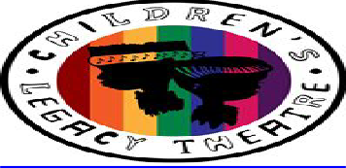

Welcome to
Our Community
Our Stage
Our World

2300 Martin Luther King, Jr. Ave, SE
Washington, DC 20020

(202) 997-1856

Childrenslegacytheatre8@gmail.com
www.childrenslegacytheatre8.org

CLT’s FIRST EVER
News Broadcast TV Show

10-Minute Play Festival
Created By
Ward 7& 8 Youth

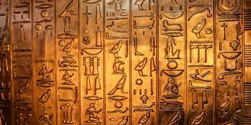
Children’s Legacy Theatre’s News Broadcast is a once in a lifetime opportunity for youth to speak up and share current events happening in and around their communities and neighborhoods.

The 10-Min Play Festival is an opportunity for young, early-career playwrights ages 14 – 17 to produce four original plays in its regular season.
Anacostia Art Center
1231 Marion Barry Ave SE, Washington, DC 20020

June 15th – 16th, 2024 @ 6:30PM
Anacostia Art Center
1231 Marion Barry Ave SE, Washington, DC 20020

August 2nd – 4th, 2024 @ 6:30PM
Fannie Lou Hamer
Until I’m Free…
Written By
Wali Jamal Abdullah
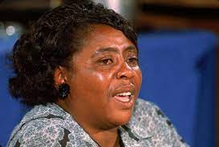

Fannie Lou Townsend Hamer rose from humble beginnings in the Mississippi Delta to become one of the most important, enthusiastic, and powerful voices of the civil and voting rights movements and a leader in the efforts for greater economic opportunities for African Americans.

Matthews Memorial Baptist Church
2616 Martin Luther King, Jr. Ave SE, Washington, DC 20020

December 20th – 22nd, 2024 @ 6:30PM

